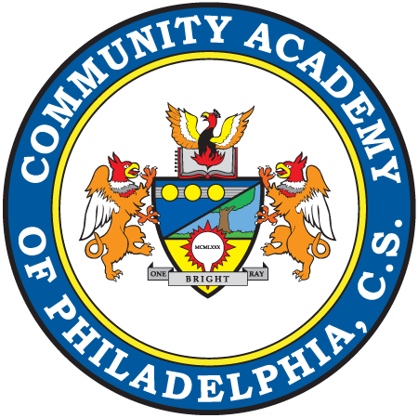
ALBERTA DILONARDO PROIETTA
ELEMENTARY SCHOOL
1100 East Erie Avenue
Philadelphia, PA 19124

T 215.533.6700
F 215.533.6722

www.communityacademy.org

Community Academy of Philadelphia
a Pennsylvania Charter School

Fourth Grade School Supply List
2021-2022

Below is the list of supplies that your child will need for the 2021-2022 school year. For your convenience many items are available at the Bear’s Den (School Store).

The extra supplies that your child will be bringing in will be put into their own personal bag to be used if they forget their supplies or run out of something.

□ 6 Marble Copybooks
□ 1 Bottle of Elmer’s Glue
□ 2 packs of Glue Sticks
□ 2 Boxes of Crayons (24 pack or smaller) NO MARKERS OR COLORED PENCILS
□ 3 Packs of No. 2 Pencils (NO mechanical pencils)
□ 1 Large Pencil Case (No Boxes: they will be sent back home!)
□ 2 highlighters
□ 2 Large Erasers
□ 2 Pairs of Blunt Tip Scissors
□ 8 Plastic Folders (one of each: red, green, blue, purple, black, yellow, orange, and 1 of your choice)
□ 1 Box of Tissues
□ 1 pack of index cards
□ 3 packs of Expo markers
□ 1 pair of earbuds (NO HEADPHONES)
□ Last names A-M: 1 Roll of Paper Towels and 1 box of gallon size baggies
□ Last names N-Z: Clorox Wipes and 1 box of quart size baggies

Please note:
· Students are expected to come prepared with the listed items each day.
· All workbooks must be covered in clear contact paper.

